How to sign an app in android?

Generate a key and keystore

You can generate an app signing or upload key using Android Studio, using the following steps:

1. In the menu bar, click **Build** > **Generate Signed APK**.
2. Select a module from the drop down, and click **Next**.
3. Click **Create new** to create a new key and keystore.
4. On the **New Key Store** window, provide the following information for your keystore and key, as shown in figure 3.

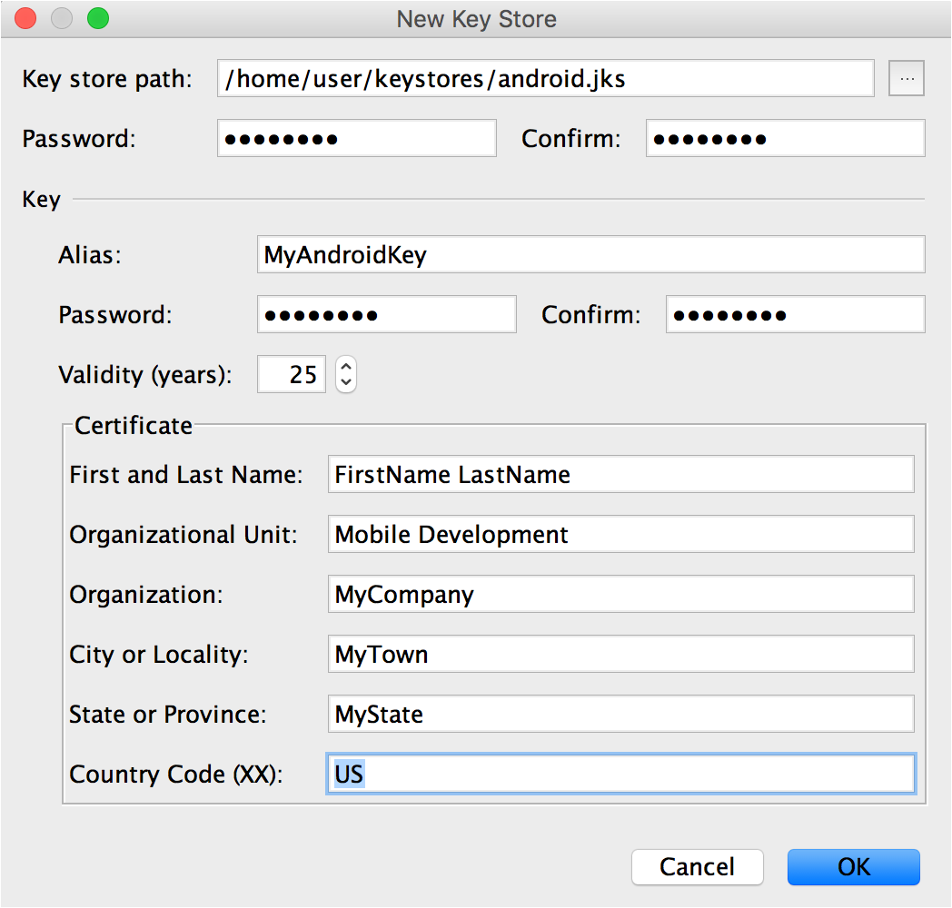

**Figure 3**. Create a new keystore in Android Studio.

**Keystore**

* + **Key store path:** Select the location where your keystore should be created.
  + **Password:** Create and confirm a secure password for your keystore.

**Key**

* + **Alias:** Enter an identifying name for your key.
  + **Password:** Create and confirm a secure password for your key. This should be different from the password you chose for your keystore
  + **Validity (years):** Set the length of time in years that your key will be valid. Your key should be valid for at least 25 years, so you can sign app updates with the same key through the lifespan of your app.
  + **Certificate:** Enter some information about yourself for your certificate. This information is not displayed in your app, but is included in your certificate as part of the APK.

Once you complete the form, click **OK**.

1. Continue on to [Manually sign an APK](https://developer.android.com/studio/publish/app-signing.html#release-mode) if you would like to generate an APK signed with your new key, or click **Cancel** if you only want to generate a key and keystore, not sign an APK.
2. If you would like to opt in to use Google Play App Signing, proceed to [Manage your app signing keys](https://support.google.com/googleplay/android-developer/answer/7384423) and follow the instructions to set up Google Play App Signing.